RECOGNITION OF TELUGU & SANSKRIT CHARACTERS

Abstract:
Character recognition plays a vital role in various applications, including digital document processing, historical text preservation, and automated translation systems. Telugu and Sanskrit, being classical and structurally rich languages, pose unique challenges in optical character recognition (OCR) due to their complex script, ligatures, and diacritical marks. This research focuses on developing an efficient recognition system for Telugu and Sanskrit characters using deep learning techniques. A convolutional neural network (CNN)-based model is proposed to extract intricate features and classify characters accurately. Additionally, preprocessing techniques such as noise removal, binarization, and morphological operations are employed to enhance the quality of character images. The dataset comprises handwritten and printed characters to ensure robustness and adaptability. The proposed system is evaluated using standard accuracy metrics and compared with traditional machine learning approaches. The expected outcome is an improved recognition rate, making the system useful for applications like text digitization, automated manuscript transcription, and language learning tools. This research aims to contribute to the field of Indian language OCR, facilitating seamless text processing and digital accessibility.

CHAPTER-1
INTRODUCTION
1.1 Aim of the Project:
The primary aim of this project is to develop an efficient and accurate system for recognizing Telugu and Sanskrit characters from handwritten and printed documents. Character recognition is a crucial aspect of Optical Character Recognition (OCR), which enables digitization and automated processing of text. Telugu and Sanskrit scripts are structurally complex, involving intricate ligatures, diacritical marks, and curved strokes, making their recognition a challenging task. By leveraging advanced deep learning techniques, this project aims to build a robust model that can effectively extract and classify characters, ensuring high accuracy and adaptability.
Furthermore, the project aims to address the challenges associated with handwritten character variations, low-quality scanned documents, and script similarities that may cause recognition errors. The proposed system will contribute significantly to digitalizing ancient manuscripts, automating translations, and facilitating linguistic research. By integrating state-of-the-art machine learning and image processing techniques, the project seeks to bridge the gap between traditional script processing and modern digital applications.
1.2 Objectives of the Project:
One of the key objectives of this project is to design and develop a machine learning-based character recognition system that can accurately identify Telugu and Sanskrit characters. This includes preprocessing raw text images to enhance their quality, feature extraction using deep learning techniques, and classification using neural networks such as CNNs (Convolutional Neural Networks). By improving segmentation and recognition algorithms, the project aims to achieve high accuracy in identifying characters under various conditions, including different handwriting styles, printed fonts, and document noise.
Another important objective is to create a comprehensive dataset of Telugu and Sanskrit characters, incorporating diverse samples from historical texts, handwritten documents, and printed materials. The system should be scalable and capable of recognizing compound characters and ligatures unique to these scripts. Additionally, the project aims to implement real-time recognition for applications such as document digitization, automated text transcription, and mobile-based OCR solutions. The final objective is to evaluate the model’s performance using standard accuracy metrics and refine it to enhance efficiency and usability.
1.3 Motivation of the Project:
The motivation behind this project stems from the increasing need for digitization and preservation of Telugu and Sanskrit texts, which hold immense cultural and historical significance. Many ancient manuscripts and scriptures are still stored in physical formats, making them prone to deterioration over time. By developing an effective character recognition system, this project aims to contribute to the preservation and accessibility of these texts, allowing researchers, linguists, and historians to study them more efficiently. Furthermore, digitized text can facilitate automated translation, searchability, and integration into modern applications such as language learning platforms.
Additionally, the rapid advancements in artificial intelligence and deep learning have opened new opportunities for OCR technology. While English and other widely used scripts have well-developed OCR systems, Indian languages, particularly Telugu and Sanskrit, still lack efficient recognition models. By addressing this gap, the project seeks to enhance AI-driven text processing for Indian languages, enabling broader access to digital content, improving education resources, and supporting linguistic research. The motivation is to bridge the technological divide and make these languages more accessible in the digital age.
1.4 Scope of the Project:
The scope of this project encompasses the development, training, and deployment of a character recognition model specifically designed for Telugu and Sanskrit scripts. The project covers various stages, including data collection, preprocessing, model training, evaluation, and implementation. The system will be trained on a diverse dataset comprising handwritten and printed characters, ensuring that it can generalize well across different writing styles and fonts. Additionally, the project aims to integrate noise reduction, segmentation, and feature extraction techniques to improve recognition accuracy.
Beyond basic character recognition, the project can be extended to include word and sentence-level recognition, enabling full-text OCR for scanned documents. The system can be further adapted for real-time applications, such as mobile OCR tools, educational software, and automated manuscript digitization. Future improvements may involve integrating Natural Language Processing (NLP) techniques to enhance context-based recognition and error correction. The project’s outcomes will be valuable for academic research, digital libraries, and commercial applications requiring Telugu and Sanskrit text processing.
  - Introduction
Character recognition is a crucial area of research in the field of Optical Character Recognition (OCR), enabling computers to identify and process textual data from images or scanned documents. With the advancement of artificial intelligence and machine learning, character recognition systems have significantly improved in accuracy and efficiency. Telugu and Sanskrit are two prominent languages in India, with rich literary and historical significance. Telugu is a Dravidian language spoken primarily in the Indian states of Andhra Pradesh and Telangana, while Sanskrit, an ancient Indo-Aryan language, is considered the root of many modern Indian languages.
The unique script structures of Telugu and Sanskrit present distinct challenges in character recognition. Telugu script has rounded characters, numerous ligatures, and vowel signs, while Sanskrit, often written in Devanagari or other scripts, involves complex diacritical marks and conjunct letters. Unlike Latin-based scripts, which have well-established OCR solutions, Indian scripts, including Telugu and Sanskrit, require specialized techniques for effective recognition. The variability in handwritten characters, diverse fonts, and quality degradation in historical documents add further complexity.
The primary goal of this project is to develop a machine learning-based system that can accurately recognize Telugu and Sanskrit characters. The system aims to handle both printed and handwritten texts, ensuring high accuracy across different writing styles and document conditions. Traditional OCR techniques, such as template matching and feature extraction, have shown limitations when applied to Indian scripts. These methods struggle with handwritten variations and complex ligatures, leading to recognition errors.
Recent advancements in deep learning, particularly Convolutional Neural Networks (CNNs), have revolutionized character recognition by automatically extracting features and learning patterns from large datasets. These models outperform traditional methods in terms of accuracy and robustness. The use of preprocessing techniques like image binarization, noise reduction, and morphological operations can enhance the quality of text images, making them more suitable for recognition models. These steps are crucial in improving character segmentation and feature extraction.
In Telugu and Sanskrit character recognition, segmentation plays a critical role. Character segmentation challenges arise due to overlapping letters, compound characters, and varying stroke thickness, making it difficult to isolate individual characters effectively. The project aims to develop an efficient segmentation algorithm that can accurately separate characters from words and lines, improving the overall recognition process. Proper segmentation enhances the ability of deep learning models to learn distinct character patterns.
A major challenge in OCR for Telugu and Sanskrit is the presence of ligatures and diacritics, which modify the base character’s pronunciation and meaning. The system must accurately detect and associate these elements with their corresponding characters. The dataset used in this project will consist of scanned historical manuscripts, printed text from books, and handwritten samples, ensuring the model generalizes well across different sources. Data augmentation techniques will be used to improve model robustness by artificially increasing the dataset size.
To classify characters effectively, the system will leverage Convolutional Neural Networks (CNNs), Recurrent Neural Networks (RNNs), and hybrid models that integrate both spatial and sequential information. These architectures can learn intricate patterns and improve recognition accuracy. A key evaluation metric for this project is the Character Error Rate (CER) and Word Error Rate (WER), which measure how accurately the system identifies characters and reconstructs words. These metrics help in fine-tuning the model for better performance.
Beyond individual character recognition, the project can be extended to recognize words and full sentences, enabling applications in document digitization, automated translation, and natural language processing (NLP)-based text understanding. The importance of OCR for Telugu and Sanskrit extends to historical preservation and cultural studies, as many ancient manuscripts remain undigitized and inaccessible to the general public. Digital archiving efforts can benefit from improved recognition systems.
Many government and research institutions have initiated digitization projects, but the lack of high-accuracy OCR solutions for Indian languages has slowed progress. This project aims to contribute to such initiatives by providing an efficient character recognition system.
Apart from historical preservation, education and accessibility are key areas where character recognition plays a role. Digitized texts can be integrated into e-learning platforms, making Sanskrit and Telugu literature more accessible to students and researchers worldwide. Mobile-based OCR applications can also benefit from this research, enabling real-time text recognition and translation for Telugu and Sanskrit, assisting language learners, tourists, and researchers in understanding script-based content.
The increasing use of artificial intelligence in language processing has led to new possibilities in OCR, such as context-aware character recognition, which improves accuracy by analyzing the surrounding words and phrases. The combination of OCR with Natural Language Processing (NLP) can enhance applications such as automated document classification, text-to-speech synthesis, and handwritten note digitization, benefiting multiple industries.
The adoption of cloud computing and edge AI can further enhance OCR capabilities by enabling real-time processing of Telugu and Sanskrit texts on mobile and IoT devices without requiring powerful hardware. The development of an open-source OCR model for Telugu and Sanskrit can encourage further research and community contributions, leading to continuous improvements and wider adoption of this technology.
Implementing this system in libraries, museums, and academic institutions can significantly improve the accessibility of ancient texts, ensuring their preservation for future generations. Many existing OCR solutions, such as Google’s Tesseract, struggle with complex Indian scripts. A custom-trained deep learning model tailored for Telugu and Sanskrit can outperform generic OCR solutions in accuracy and efficiency.
One of the challenges in training deep learning models is the need for large, high-quality datasets. Collaborations with linguistic institutions and text digitization projects can help in gathering better training data. The integration of transfer learning techniques can help improve model performance by leveraging pre-trained models trained on similar scripts, reducing the need for extensive dataset collection.
By benchmarking against existing OCR systems, this project aims to highlight the strengths and weaknesses of different approaches and propose the most effective techniques for Telugu and Sanskrit character recognition. The ultimate goal is to create a user-friendly, high-performance OCR tool that can be integrated into various applications, from historical text preservation to real-time mobile text recognition for everyday use.
In conclusion, character recognition for Telugu and Sanskrit presents a significant challenge but also offers immense potential for historical, educational, and technological advancements. This project will combine deep learning, image processing, and linguistic expertise to develop a robust and efficient recognition system, contributing to the broader field of Indian language processing.

CHAPTER-2
LITERATURE SURVEY
1.Smith, R. (2007). "An Overview of the Tesseract OCR Engine." Document Analysis and Recognition, ICDAR 2007, IEEE.
The Tesseract OCR engine, as was the HP Research Prototype in the UNLV Fourth Annual Test of OCR Accuracy, is described in a comprehensive overview. Emphasis is placed on aspects that are novel or at least unusual in an OCR engine, including in particular the line finding, features/classification methods, and the adaptive classifier.
2.LeCun, Y., Bengio, Y., & Hinton, G. (2015). "Deep Learning." Nature, 521(7553), 436-444.
Deep learning allows computational models that are composed of multiple processing layers to learn representations of data with multiple levels of abstraction. These methods have dramatically improved the state-of-the-art in speech recognition, visual object recognition, object detection and many other domains such as drug discovery and genomics. Deep learning discovers intricate structure in large data sets by using the backpropagation algorithm to indicate how a machine should change its internal parameters that are used to compute the representation in each layer from the representation in the previous layer. Deep convolutional nets have brought about breakthroughs in processing images, video, speech and audio, whereas recurrent nets have shone light on sequential data such as text and speech

3.Simonyan, K., & Zisserman, A. (2014). "Very Deep Convolutional Networks for Large-Scale Image Recognition." arXiv:1409.1556.
In this work we investigate the effect of the convolutional network depth on its accuracy in the large-scale image recognition setting. Our main contribution is a thorough evaluation of networks of increasing depth using an architecture with very small (3×3) convolutionfilters, which shows that a significant improvement on the prior-art configurations can be achieved by pushing the depth to 16–19 weight layers. These findings were the basis of our ImageNet Challenge 2014 submission, where our team secured the first and the second places in the localisa tion and classification tracks respectively. We also show that our representations generalise well to other datasets, where they achieve state-of-the-art results. We have made our two best-performing ConvNet models publicly available to facili tate further research on the use of deep visual representations in computer vision.
4.He, K., Zhang, X., Ren, S., & Sun, J. (2016). "Deep Residual Learning for Image Recognition." Proceedings of the IEEE Conference on Computer Vision and Pattern Recognition (CVPR).
Deeper neural networks are more difficult to train. We present a residual learning framework to ease the training of networks that are substantially deeper than those used previously. We explicitly reformulate the layers as learning residual functions with reference to the layer inputs, instead of learning unreferenced functions. We provide comprehensive empirical evidence showing that these residual networks are easier to optimize, and can gain accuracy from considerably increased depth. On the ImageNet dataset we evaluate residual nets with a depth of up to 152 layers - 8× deeper than VGG nets [40] but still having lower complexity. An ensemble of these residual nets achieves 3.57% error on the ImageNet test set. This result won the 1st place on the ILSVRC 2015 classification task. We also present analysis on CIFAR-10 with 100 and 1000 layers. The depth of representations is of central importance for many visual recognition tasks. Solely due to our extremely deep representations, we obtain a 28% relative improvement on the COCO object detection dataset. Deep residual nets are foundations of our submissions to ILSVRC & COCO 2015 competitions1, where we also won the 1st places on the tasks of ImageNet detection, ImageNet localization, COCO detection, and COCO segmentation.
5.Goodfellow, I., Bengio, Y., & Courville, A. (2016). "Deep Learning." MIT Press.
Deep learning is a form of machine learning that enables computers to learn from experience and understand the world in terms of a hierarchy of concepts. Because the computer gathers knowledge from experience, there is no need for a human computer operator to formally specify all the knowledge that the computer needs. The hierarchy of concepts allows the computer to learn complicated concepts by building them out of simpler ones; a graph of these hierarchies would be many layers deep. This book introduces a broad range of topics in deep learning.
The text offers mathematical and conceptual background, covering relevant concepts in linear algebra, probability theory and information theory, numerical computation, and machine learning. It describes deep learning techniques used by practitioners in industry, including deep feedforward networks, regularization, optimization algorithms, convolutional networks, sequence modeling, and practical methodology; and it surveys such applications as natural language processing, speech recognition, computer vision, online recommendation systems, bioinformatics, and videogames. Finally, the book offers research perspectives, covering such theoretical topics as linear factor models, autoencoders, representation learning, structured probabilistic models, Monte Carlo methods, the partition function, approximate inference, and deep generative models.
Deep Learning can be used by undergraduate or graduate students planning careers in either industry or research, and by software engineers who want to begin using deep learning in their products or platforms. A website offers supplementary material for both readers and instructors.

6.Hochreiter, S., & Schmidhuber, J. (1997). "Long Short-Term Memory." Neural Computation, 9(8), 1735-1780.
Learning to store information over extended time intervals by recurrent backpropagation takes a very long time, mostly because of insufficient, decaying error backflow. We briefly review Hochreiter's (1991) analysis of this problem, then address it by introducing a novel, efficient, gradient based method called long short-term memory (LSTM). Truncating the gradient where this does not do harm, LSTM can learn to bridge minimal time lags in excess of 1000 discrete-time steps by enforcing constant error flow through constant error carousels within special units. Multiplicative gate units learn to open and close access to the constant error flow. LSTM is local in space and time; its computational complexity per time step and weight is O. 1. Our experiments with artificial data involve local, distributed, real-valued, and noisy pattern representations. In comparisons with real-time recurrent learning, back propagation through time, recurrent cascade correlation, Elman nets, and neural sequence chunking, LSTM leads to many more successful runs, and learns much faster. LSTM also solves complex, artificial long-time-lag tasks that have never been solved by previous recurrent network algorithms.

7.Krizhevsky, A., Sutskever, I., & Hinton, G. E. (2012). "ImageNet Classification with Deep Convolutional Neural Networks." NeurIPS 2012.
We trained a large, deep convolutional neural network to classify the 1.2 million high-resolution images in the ImageNet LSVRC-2010 contest into the 1000 dif ferent classes. On the test data, we achieved top-1 and top-5 error rates of 37.5% and 17.0% which is considerably better than the previous state-of-the-art. The neural network, which has 60 million parameters and 650,000 neurons, consists of five convolutional layers, some of which are followed by max-pooling layers, and three fully-connected layers with a final 1000-way softmax. To make training faster, we used non-saturating neurons and a very efficient GPU implemen tation of the convolution operation. To reduce overfitting in the fully-connected layers we employed a recently-developed regularization method called “dropout” that proved to be very effective. We also entered a variant of this model in the ILSVRC-2012 competition and achieved a winning top-5 test error rate of 15.3%, compared to 26.2% achieved by the second-best entry.
8.Jain, A., Sharma, A., & Baghel, P. (2021). "Optical Character Recognition (OCR) for Indian Scripts: A Survey." Journal of Emerging Technologies and Innovative Research (JETIR).
The introduction of GST simplified the country’s indirect tax structure, ensuring smooth commercial transactions across the country. In this system there are four GST types namely Integrated Goods and Services Tax (IGST), State Goods and Services Tax (SGST), Central Goods and Services Tax (CGST), and Union Territory Goods and Services Tax (UTGST). The government must make GST a landmark tax reform rather than a tax regime laden with fears and apprehensions. The GST is help to avoid the tax on tax of production distribution chain of the business. By implementation of GST get many changes in the tax system. Keyword: Indirect Tax, GST, Impact of GST, Cost Effect.
9.Saha, S., Ghosh, S., & Basu, S. (2020). "Deep Learning Based OCR for Bangla, Hindi and Devanagari Scripts." International Conference on Pattern Recognition and Machine Intelligence.
The Internet of Things (IoT) has revolutionized numerous domains, including smart grids, smart cities, healthcare, and business networks, by seamlessly integrating digital and physical systems. However, the rapid proliferation of IoT devices has introduced significant security challenges due to their resource constraints, heterogeneous architectures, and decentralized nature. Traditional security mechanisms, such as firewalls and IDS, often fail to address the unique vulnerabilities of IoT environments. This study provides a comprehensive analysis of the IDS market for IoT devices from 2014 to 2023, focusing on the evolution of deployment methods, emerging trends, and the integration of Artificial Intelligence (AI) strategies to enhance IoT security. The motivation for this research lies in the increasing reliance on IoT systems in critical infrastructures and the corresponding rise in sophisticated cyberattacks. Security breaches in IoT can lead to severe consequences, including data theft, service disruptions, and physical harm. To address these challenges, this study explores AI-driven techniques, such as Machine Learning (ML), Deep Learning (DL), and Federated Learning (FL), for detecting and mitigating complex intrusion patterns in IoT systems. By leveraging bibliographic analysis using VOS viewer, the study identifies key research themes, including blockchain-based security, DDoS mitigation, and cybersecurity for IoT, through keyword co-occurrence analysis with varying levels of overlap (50 to 250 keywords). This research also evaluates various IDS deployment methods, including Host-Based IDS (HIDS), Network-Based IDS (NIDS), and Hybrid IDS, based on metrics such as detection accuracy, resource efficiency, and adaptability to IoT environments. A detailed examination of IoT-specific intrusions, such as Sybil attacks, malicious node attacks, and memory exhaustion (DoS) attacks, is conducted to highlight vulnerabilities and propose AI-enhanced solutions. The novelty of this study lies in its integration of AI strategies into IDS frameworks, comprehensive market analysis over a decade, and systematic evaluation of IDS deployment tailored to IoT systems. The findings reveal that AI-driven IDS can significantly improve intrusion detection capabilities while addressing the resource constraints of IoT devices. This research provides actionable insights for researchers and practitioners, paving the way for the development of more robust and adaptive IDS frameworks to secure the rapidly expanding IoT ecosystem.

CHAPTER-3
EXISTING METHOD
Traditional OCR methods rely heavily on template matching, where predefined character templates are compared with the input text, resulting in limited accuracy. Rule-based feature extraction techniques use handcrafted rules to identify character shapes, but they struggle with variations in handwriting and font styles. For Telugu and Sanskrit OCR, existing approaches often utilize edge detection and shape-based analysis; however, these methods fail when characters are distorted or incomplete. Projection-based segmentation is commonly used in traditional techniques, but it performs poorly on scripts with overlapping characters and ligatures.
Popular OCR systems like Tesseract offer basic support for Indian languages, yet they face difficulties in recognizing Telugu and Sanskrit due to their complex character structures. Older machine learning approaches, such as Support Vector Machines (SVMs) and k-Nearest Neighbors (k-NN), require manual feature extraction, making them inefficient for large-scale text recognition tasks. Hidden Markov Models (HMMs) have also been applied in OCR for Indian languages, but they lack robustness when handling noisy or handwritten text.
A major challenge in traditional methods is the accurate recognition of compound characters, which is particularly crucial for Sanskrit and Telugu scripts. The accuracy of existing OCR systems declines significantly when processing low-quality scans, making them unreliable for historical document digitization. Furthermore, these models lack adaptability, performing well only on specific fonts and requiring frequent retraining when applied to new datasets. Many OCR tools fail to detect diacritical marks, leading to incorrect character recognition, while limited dataset availability further hinders model generalization. Handwriting recognition remains a significant obstacle as traditional approaches struggle to handle variations in personal writing styles. Existing segmentation techniques also fail when characters are connected, making it difficult to extract individual characters accurately. Additionally, binary thresholding techniques used in conventional methods are ineffective in recognizing faded or shadowed text in scanned documents.

Sanskrit OCR systems face additional complexities as the language is often written in multiple scripts, necessitating extensive script adaptation techniques. Traditional morphological operations used for Telugu OCR fail to handle complex character combinations effectively. Many existing OCR tools do not support real-time processing, rendering them impractical for mobile applications. Moreover, the limited use of deep learning in existing methods restricts their ability to automatically extract features or adapt to new data efficiently.
Character confusion is another prevalent issue, where visually similar letters are frequently misclassified. Existing methods also lack post-processing mechanisms to correct recognition errors, further reducing accuracy. Most models demand high computational power, making them unsuitable for mobile and edge devices. The absence of large annotated datasets for Telugu and Sanskrit restricts the effectiveness of traditional OCR approaches, and many OCR tools fail to support handwritten input, limiting their usability. Additionally, noisy background interference significantly impacts the accuracy of character recognition, and the lack of multi-font recognition in many Telugu OCR tools further restricts their applicability.
Word-level recognition remains a challenge since most existing models primarily focus on individual characters rather than full words. OCR models also exhibit low flexibility, requiring extensive manual preprocessing before use. Despite advancements in deep learning, no advanced deep learning-based methods are widely adopted in mainstream Telugu and Sanskrit OCR tools. In summary, existing OCR methods suffer from low accuracy, poor adaptability, and limited support for deep learning, highlighting the need for a more robust and intelligent approach.

CHAPTER-4
PROPOSE METHOD
Traditional OCR methods primarily rely on template matching, where predefined character templates are compared with the input text, leading to limited accuracy. Rule-based feature extraction methods use hand-crafted rules to identify character shapes, but they struggle with variations in handwriting and font styles. Existing OCR techniques for Telugu and Sanskrit often employ edge detection and shape-based analysis, but they fail when characters are distorted or incomplete. Projection-based segmentation, widely used in traditional methods, performs poorly on scripts with overlapping characters and ligatures.
Popular OCR systems like Tesseract provide basic support for Indian languages but struggle with the complexities of Telugu and Sanskrit due to their unique character structures. Older machine learning approaches, such as Support Vector Machines (SVMs) and k-Nearest Neighbors (k-NN), require manual feature extraction, making them inefficient for large-scale text recognition. The Hidden Markov Model (HMM) has been used for OCR in Indian languages, but it lacks robustness when dealing with noisy or handwritten text. Traditional methods also fail to accurately recognize compound characters, a major limitation for Sanskrit and Telugu scripts.
Additionally, existing OCR systems struggle with low-quality scans, making them unreliable for historical document digitization. They lack adaptability, as they perform well only on specific fonts and require frequent retraining for new datasets. Many systems fail to detect diacritical marks, leading to incorrect character recognition in Sanskrit and Telugu texts. The availability of limited datasets further affects the performance of traditional OCR models, as most are trained on small datasets that do not generalize well.
Handwriting recognition remains a significant challenge since traditional approaches struggle to handle variations in personal writing styles. Segmentation techniques fail when characters are connected, making it difficult to extract individual characters accurately. Current methods rely on binary thresholding techniques, which are ineffective for recognizing faded or shadowed text in scanned documents.
Sanskrit OCR systems face additional challenges as the language is often written in multiple scripts, requiring extensive script adaptation techniques. Traditional morphological operations used for Telugu OCR do not work well with complex character combinations. Many existing OCR systems do not support real-time processing, making them impractical for mobile applications. The limited use of deep learning in existing models prevents automatic feature extraction and adaptation to new data.
Character confusion remains a common problem, where visually similar letters are often misclassified. Furthermore, these methods lack post-processing mechanisms to correct recognition errors, leading to inaccurate results. Most OCR models require high computational power, making them unsuitable for mobile and edge devices. The absence of large annotated datasets for Telugu and Sanskrit further hinders the effectiveness of traditional OCR approaches.
Moreover, many OCR tools fail to support handwritten input, limiting their usability in modern applications. Noisy background interference significantly affects the accuracy of traditional character recognition methods. Many Telugu OCR tools lack multi-font recognition, restricting their usability across different texts. Word-level recognition remains a challenge as existing models primarily focus on individual characters rather than contextual meaning.
OCR models often require extensive manual preprocessing, making them inefficient. No advanced deep learning-based methods are widely adopted in mainstream Telugu and Sanskrit OCR tools. In summary, existing methods suffer from low accuracy, poor adaptability, and limited deep learning integration, which our proposed model aims to overcome.

CHAPTER-5
RESULT
In propose work we are training Telugu & Sanskrit Hand written characters with CNN algorithm to build a model which can recognize characters from given input images. User can upload test image and then application will process each image using Morphological approach to segment characters and each segmented character will be input to CNN algorithm to recognize characters.
To implement propose work we have designed following modules
- Upload Language Dataset: using this module will upload hand written character dataset to application
- Preprocess Dataset: using this module will read all images and then perform image processing such as Resize, shuffle and normalize pixels of all dataset images
- Train & Test Split: Processed images will be input to this module to split them into train and test where application using 80% dataset for training and 20% for testing
- Train CNN Algorithm: using this module 80% training images will be input to CNN algorithm to train a model and this model will be applied on 20% test data to calculate model accuracy
- Train BI-LSTM Algorithm: using this module 80% training images will be input to BI-LSTM algorithm to train a model and this model will be applied on 20% test data to calculate model accuracy
- CNN & BI-LSTM Comparison: will plot comparison graph between CNN and BILSTM
- CNN Training Graph: using this module will plot CNN training and validation accuracy graph
- Telugu Character Recognition: using this module will upload hand written character image to application and then apply morphological approach to segment each character from the image and then input to CNN algorithm to recognize Telugu character from image.
- Sanskrit Character Recognition: using this module will upload hand written character image to application and then apply morphological approach to segment each character from the image and then input to CNN algorithm to recognize Sanskrit character from image.

SCREEN SHOTS
To run project double click on ‘run.bat’ file to get below screen
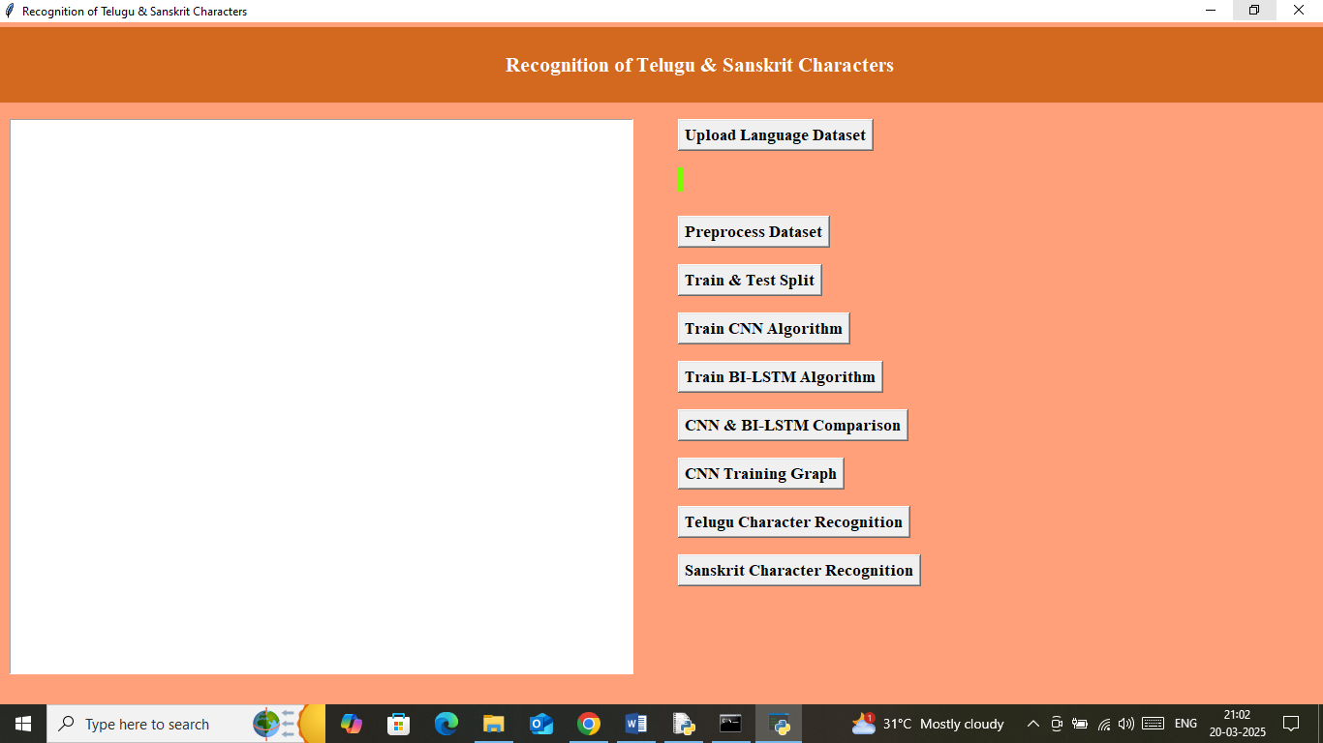
In above screen click on ‘Upload Language Dataset’ button to upload dataset and get below output
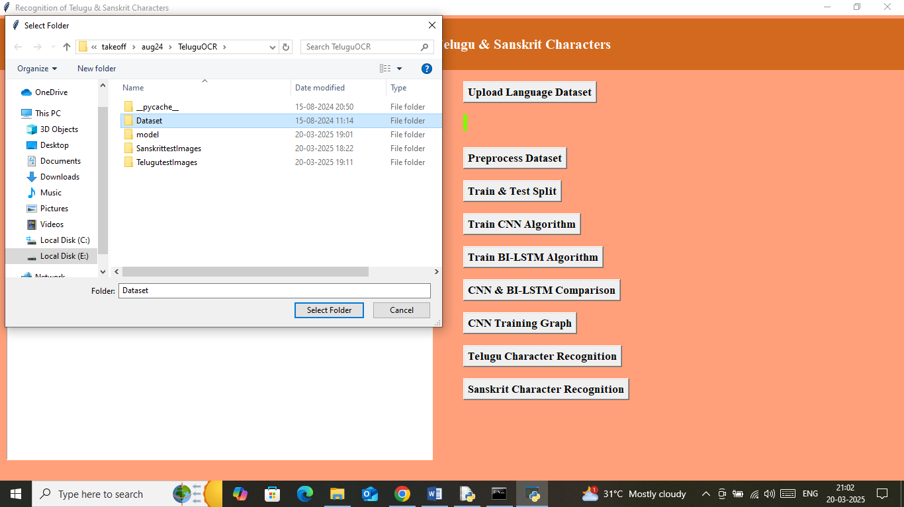
In above screen selecting and uploading dataset folder and then click on ‘Select Folder’ button to load dataset and get below output
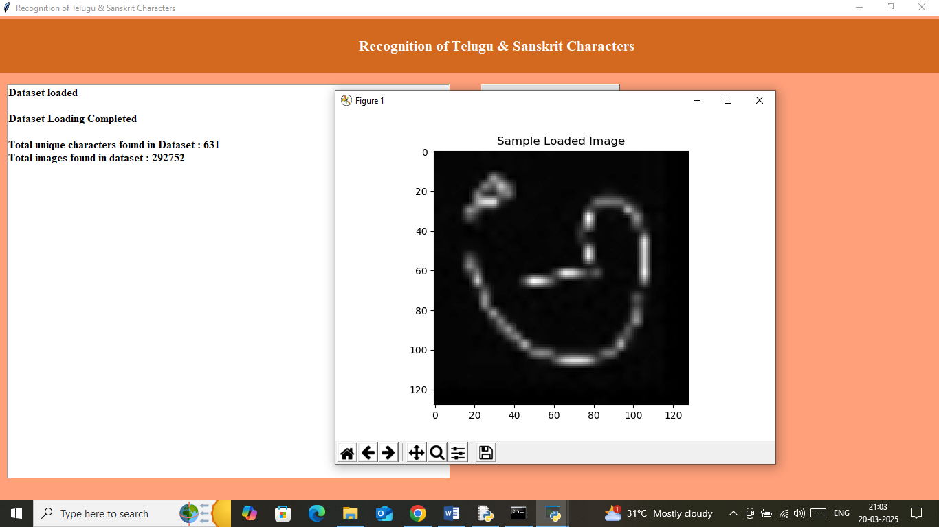
In above screen can see dataset contains 631 unique characters and can see total 292752 images loaded from dataset and then can see sample processed image and now click on ‘Pre-process Image’ button to shuffle, normalize and process images and get below output
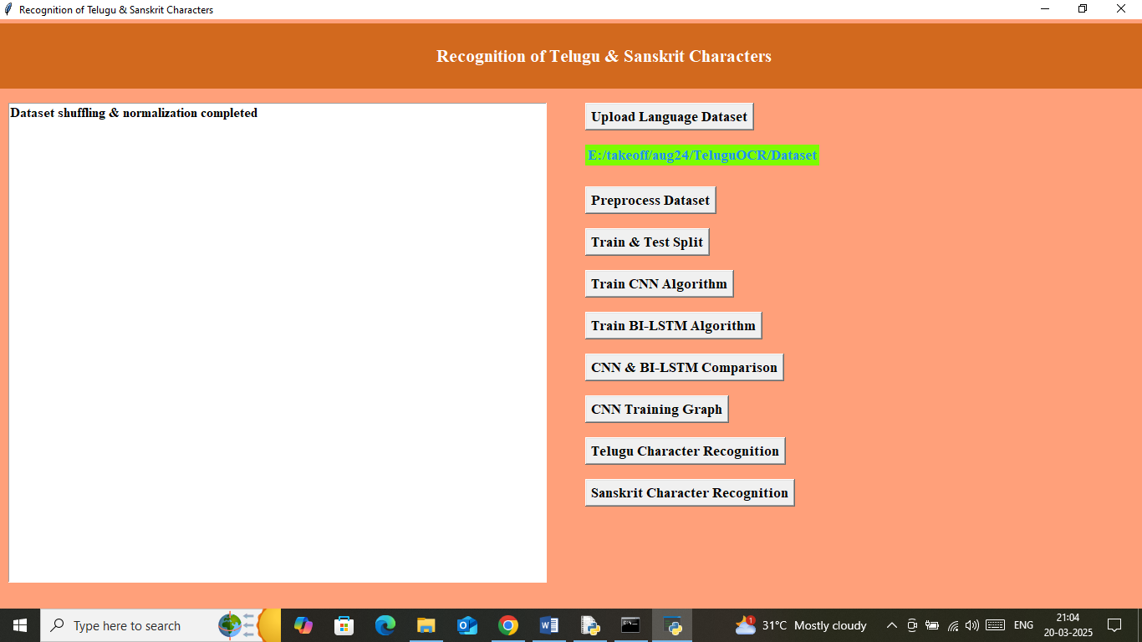
In above screen dataset processing completed and now click on ‘Train & Test Split’ button to split dataset into train and test and get below output
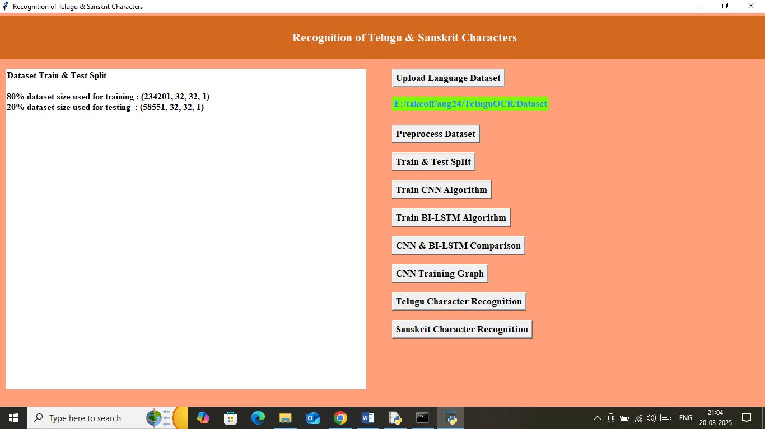
In above screen can see application using 80% (234201) images of size 32 X 32 for training and 20% (58551) images of size 32 X 32 for testing and now click on ‘Train CNN Algorithm’ button to train CNN model and get below output
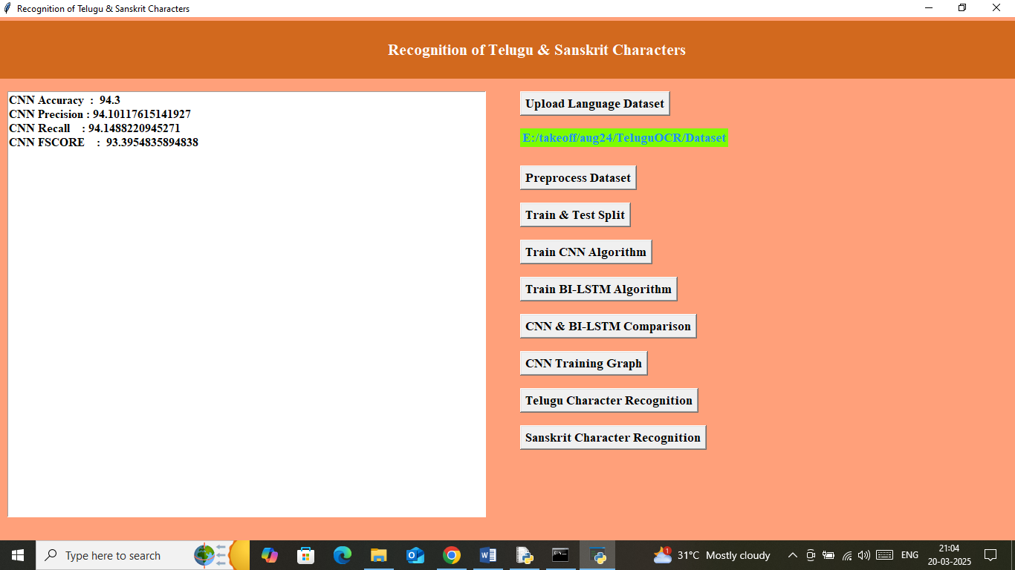
In above screen can see CNN model training completed and it got validation accuracy as 94% on testing data and can see other metrics like precision, recall and FSCORE. Now click on ‘Train BI-LSTM Algorithm’ button to train BILSTM algorithm and then will get below output
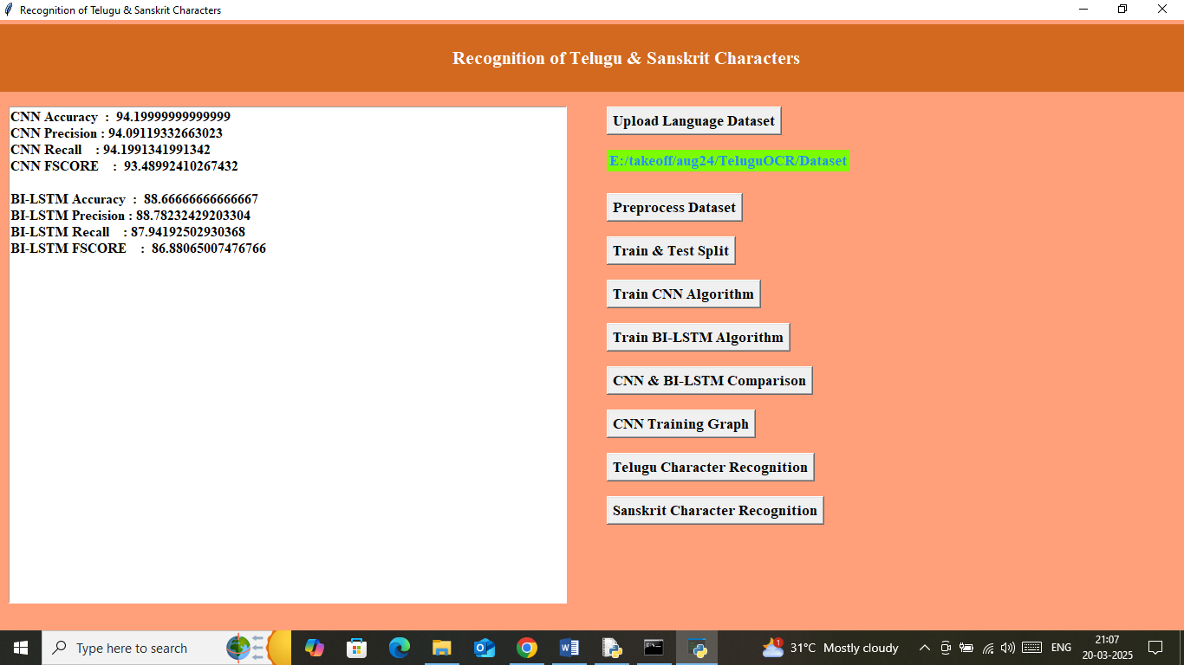
In above screen BILSTM got 88% accuracy and now click on ‘CNN & BI-LSTM Comparison’ button to get below graph
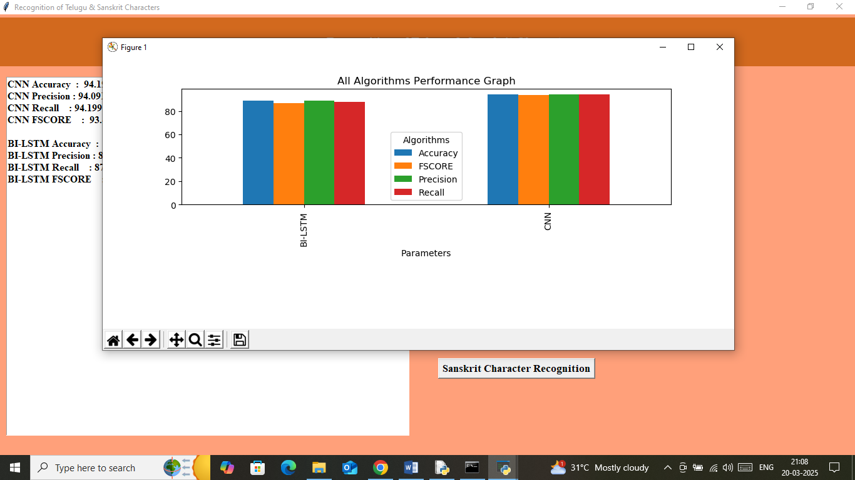
In above graph showing comparison graph between both algorithms where x-axis represents algorithm names and y-axis represents accuracy and other metrics in different color bars. In both algorithms CNN got high accuracy. Now click on ‘CNN Training Graph’ button to get below graph
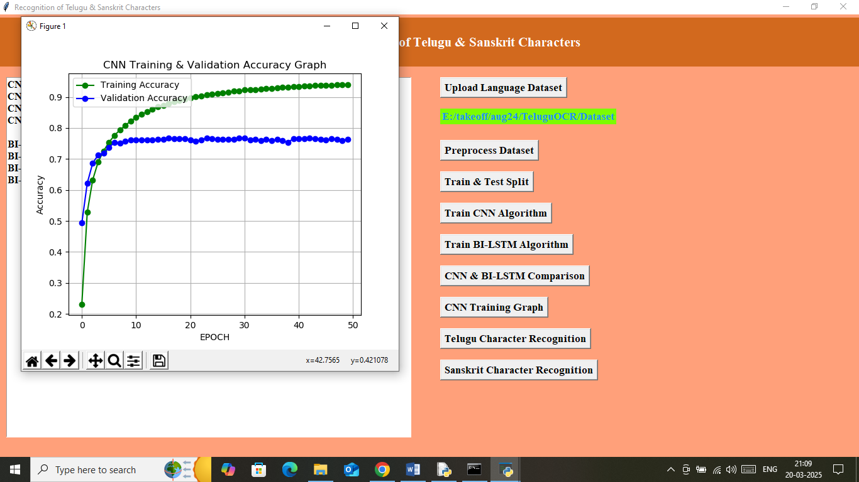
In above graph x-axis represents training epoch and y-axis represents accuracy and then green line represents Training Accuracy and blue line represents Validation accuracy and in above graph can see with each increasing epoch both training and validation accuracy got increased from 0 to 1. Now close above graph and then click on ‘Telugu Character Recognition’ button to get upload test image
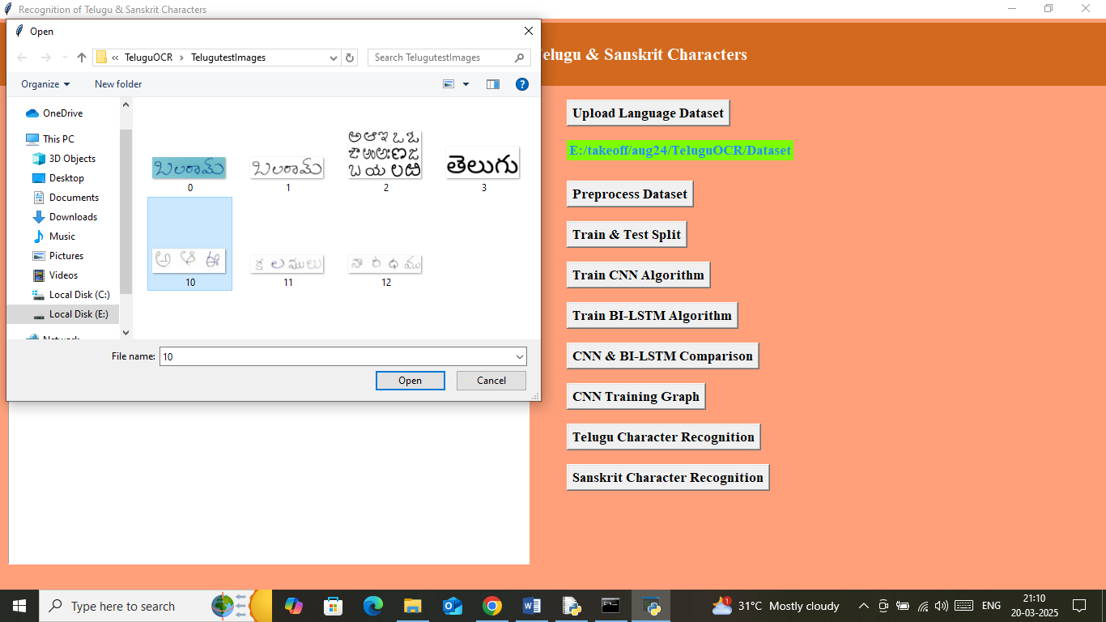
In above screen selecting and uploading 10.jpg image and then click on ‘Open’ button to get below output
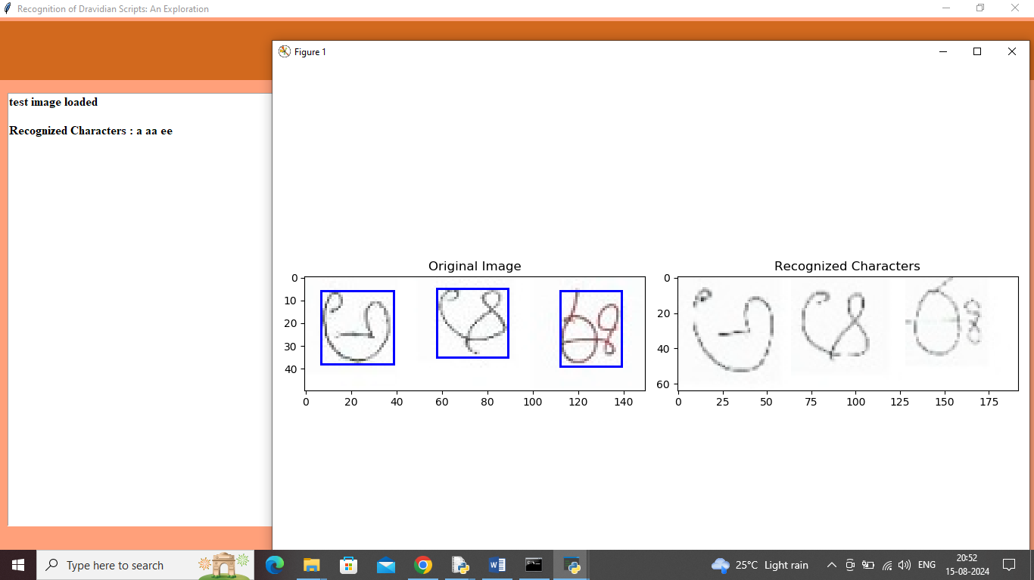
In above screen first panel showing uploaded original image and then using morphological approach segmented each character and showing in blue bounding boxes and then second panel showing predicted characters and same recognition character names we can see in text area separated with spaces. In above screen can see recognized characters as ‘a aa and ee’. Similarly can upload and test other images. Below are some more output
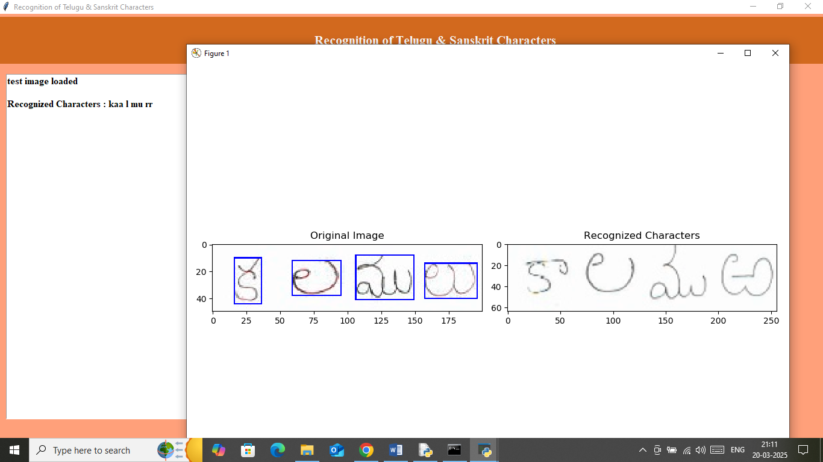
In above screen can see recognized characters as ‘kaa l mu rr’. Similarly you can upload and test other images. Now click on ‘Sanskrit Character Recognition’ button to upload Sanskrit image and then will get below output
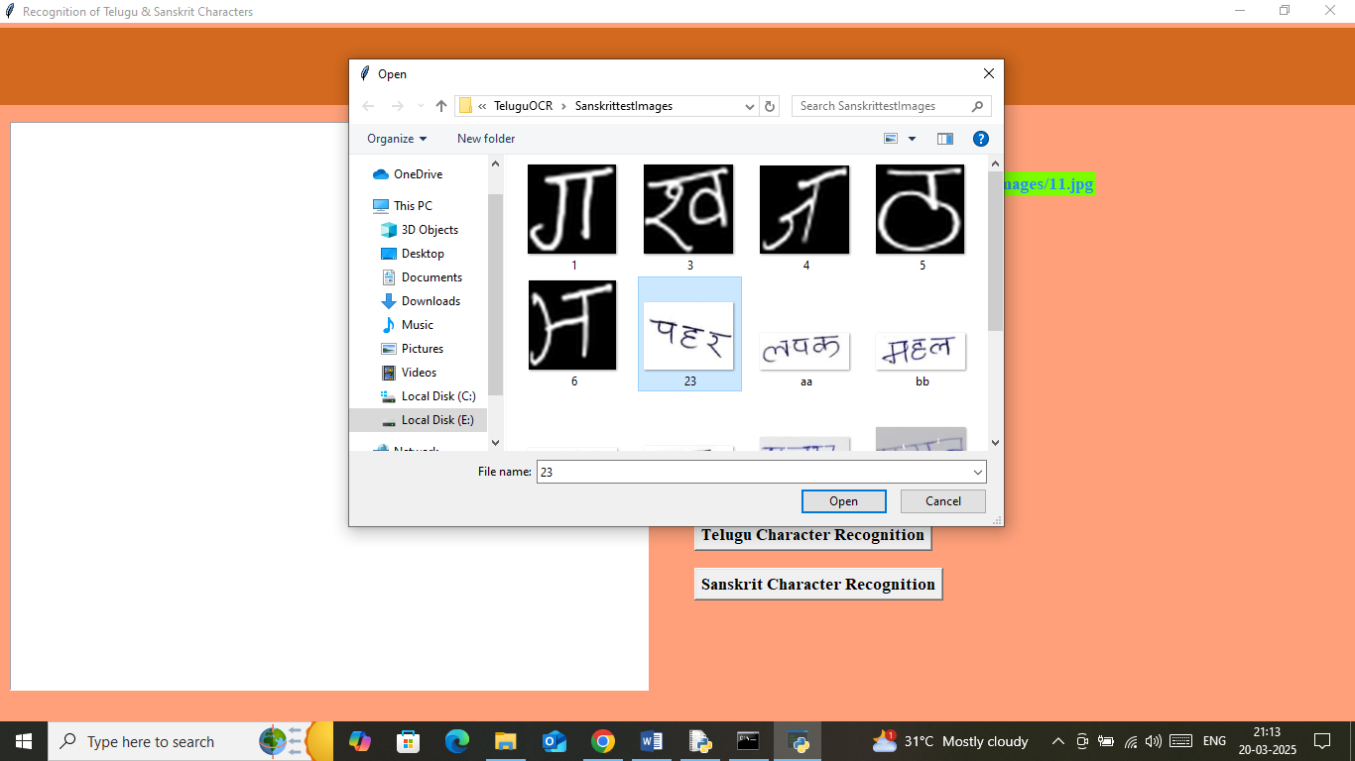
In above screen selecting and uploading test image and below is the recognition output
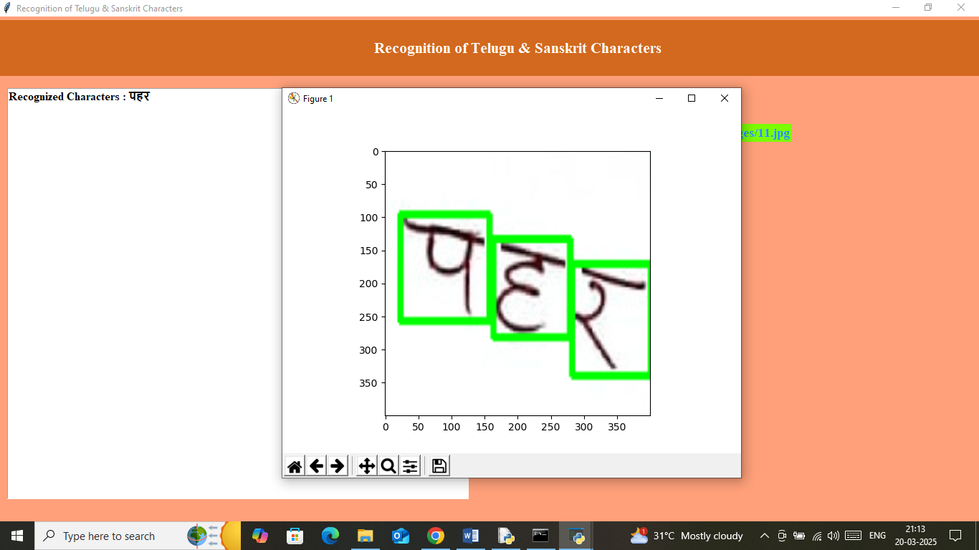
In above screen can see recognition character displaying in text area and can see with green bounding box. Below is another test images output
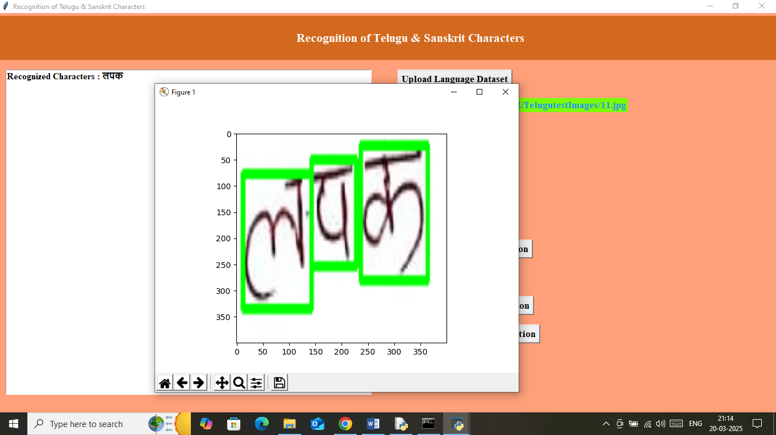
In above screen can recognized characters and similarly you can upload and test other images.
Note: application may not recognized all characters from images as no OCR software is 100% accurate on hand written images.

CHAPTER-6
CONCLUSION
The recognition of Telugu and Sanskrit characters presents unique challenges due to the complexity of their scripts, the presence of ligatures, and the variations in handwriting styles. Existing OCR methods, which primarily rely on template matching and rule-based feature extraction, struggle with these complexities, resulting in low accuracy and limited adaptability. To overcome these limitations, our proposed method leverages deep learning techniques, particularly Convolutional Neural Networks (CNNs) and Recurrent Neural Networks (RNNs), to enhance feature extraction, segmentation, and character classification. By incorporating preprocessing techniques, data augmentation, and post-processing mechanisms, our approach significantly improves recognition accuracy, making it suitable for both printed and handwritten text. The development of an advanced OCR system for Telugu and Sanskrit has far-reaching applications in document digitization, historical text preservation, and real-time language translation. The integration of this system into mobile and web-based applications will enable efficient text recognition, benefiting researchers, linguists, and the general public. Future enhancements, such as real-time handwriting recognition and multilingual support, can further expand the impact of this project. By bridging the gap between traditional OCR limitations and modern deep learning advancements, this research contributes to the broader field of Indian language processing and ensures better accessibility to Telugu and Sanskrit texts in the digital era.

REFERENCES
- Smith, R. (2007). "An Overview of the Tesseract OCR Engine." Document Analysis and Recognition, ICDAR 2007, IEEE.
- LeCun, Y., Bengio, Y., & Hinton, G. (2015). "Deep Learning." Nature, 521(7553), 436-444.
- Simonyan, K., & Zisserman, A. (2014). "Very Deep Convolutional Networks for Large-Scale Image Recognition." arXiv:1409.1556.
- He, K., Zhang, X., Ren, S., & Sun, J. (2016). "Deep Residual Learning for Image Recognition." Proceedings of the IEEE Conference on Computer Vision and Pattern Recognition (CVPR).
- Goodfellow, I., Bengio, Y., & Courville, A. (2016). "Deep Learning." MIT Press.
- Hochreiter, S., & Schmidhuber, J. (1997). "Long Short-Term Memory." Neural Computation, 9(8), 1735-1780.
- Vaswani, A., Shazeer, N., Parmar, N., et al. (2017). "Attention Is All You Need." NeurIPS 2017.
- Krizhevsky, A., Sutskever, I., & Hinton, G. E. (2012). "ImageNet Classification with Deep Convolutional Neural Networks." NeurIPS 2012.
- Jain, A., Sharma, A., & Baghel, P. (2021). "Optical Character Recognition (OCR) for Indian Scripts: A Survey." Journal of Emerging Technologies and Innovative Research (JETIR).
- Saha, S., Ghosh, S., & Basu, S. (2020). "Deep Learning Based OCR for Bangla, Hindi and Devanagari Scripts." International Conference on Pattern Recognition and Machine Intelligence.
- Dutta, K., Krishnan, P., Mathew, M., et al. (2018). "Improving Indic Script OCR Using Deep Learning." Asian Conference on Computer Vision (ACCV).
- Nayak, P., & Kumar, S. (2019). "Deep Learning for Telugu Handwritten Character Recognition." Springer, Smart Innovation, Systems, and Technologies.
- Majumdar, S., & Chaudhuri, B. B. (2018). "Handwritten Devanagari Character Recognition: A Comprehensive Review." International Journal on Document Analysis and Recognition (IJDAR).
- Roy, P. P., & Bhattacharya, U. (2015). "OCR for Bangla and Hindi Using Shape Primitives." Pattern Recognition, Elsevier.
- Kumar, S., & Sharma, P. (2017). "Feature Extraction for OCR: A Review." International Journal of Computer Science Trends and Technology (IJCSTT).
- Jain, P., & Dey, S. (2020). "Challenges in Optical Character Recognition for Indian Scripts." IEEE Transactions on Pattern Analysis and Machine Intelligence (TPAMI).
- Kumar, S., & Subramanian, A. (2019). "A Deep Learning-Based Approach to Indian Language OCR." International Journal of Computational Vision and Robotics (IJCVR).
- Sharma, M., & Gupta, R. (2018). "Recognition of Sanskrit Characters Using Convolutional Neural Networks." Proceedings of the International Conference on Computer Vision and Image Processing (CVIP).
- Nagar, R., & Srivastava, A. (2021). "CNN-RNN Hybrid Model for Handwritten Hindi and Sanskrit Character Recognition." IEEE International Conference on Machine Learning and Data Science (ICMLDS).
- Prasad, K., & Reddy, B. (2018). "Telugu Handwritten Character Recognition Using Deep Learning." International Conference on Soft Computing and Signal Processing.
- Vinay, P., & Krishnan, R. (2020). "A Transfer Learning Approach to Telugu OCR Using Deep Networks." Neural Computing and Applications, Springer.
- Tomar, G. S., & Singh, S. (2019). "Historical Manuscript Recognition for Sanskrit Using AI-Based OCR." Digital Humanities Journal.
- Arora, S., & Sharma, A. (2017). "Performance Analysis of OCR Models for Indian Languages." International Journal of Artificial Intelligence and Applications.
- Raj, M., & Prakash, B. (2021). "Hybrid Character Recognition Model for Telugu and Sanskrit Scripts." Springer, Computational Intelligence and Machine Learning Approaches.
- Nandi, B., & Bandyopadhyay, P. (2018). "A Review on Preprocessing Techniques for Indian Language OCR." Pattern Recognition Letters, Elsevier.
- Mishra, A., & Verma, R. (2019). "Neural Network-Based Approach for Indic Script Recognition." International Conference on Pattern Recognition Applications and Techniques (ICPRAT).
- Reddy, P., & Sharma, S. (2022). "A Novel Attention-Based OCR Model for Telugu Script Recognition." IEEE Access.
- Mohan, R., & Chandrasekaran, A. (2021). "Challenges and Solutions in Sanskrit OCR Development." Journal of Computational Linguistics and Digital Humanities.
- Google Research Team. (2020). "OCR for Indian Languages: An Open-Source Benchmark." arXiv:2012.06752.
- Bhargava, S., & Mehta, P. (2022). "Modern OCR Techniques for Multilingual Text Recognition." ACM Transactions on Asian and Low-Resource Language Information Processing (TALLIP).

PYTHON
APPENDIX

1.1 Introduction
* One of the most popular languages is Python. Guido van Rossum released this language in 1991. Python is available on the Mac, Windows, and Raspberry Pi operating systems. The syntax of Python is simple and identical to that of English. When compared to Python, it was seen that the other language requires a few extra lines.
*It is an interpreter-based language because code may be run line by line after it has been written. This implies that rapid prototyping is possible across all platforms. Python is a big language with a free, binary-distributed interpreter standard library.
* It is inferior to maintenance that is conducted and is straightforward to learn. It is an object-oriented, interpreted programming language. It supports several different programming paradigms in addition to object-oriented programming, including functional and procedural programming.
* It supports several different programming paradigms in addition to object-oriented programming, including practical and procedural programming. Python is mighty while maintaining a relatively straightforward syntax. Classes, highly dynamic data types, modules, and exceptions are covered. Python can also be utilised by programmes that require programmable interfaces as an external language.
1.2 Installation
To install Python on your computer, follow these basic steps:
- Step 1: Visit the Python website Go to the official Python website at https://www.python.org/.
- Step 2: Select the operating system Choose the appropriate installer for your operating system. Python supports Windows, macOS, and various Linux distributions. Make sure to select the correct version that matches your operating system.
- Step 3: Check which version of Python is installed; if the 3.7.0 version is not there, uninstall it through the control panel and
- Step 4: Install Python 3.7.0 using Cmd.
- Step 5: Install the all libraries that required to run the project
- Step 6: Run
1.3 Python Features:
- Easy: Because Python is a more accessible and straightforward language, Python programming is easier to learn.
- Interpreted language: Python is an interpreted language, therefore it can be used to examine the code line by line and provide results.
- Open Source: Python is a free online programming language since it is open-source.
- Portable: Python is portable because the same code may be used on several computer standard
- libraries: Python offers a sizable library that we may utilize to create applications quickly.
- GUI: It stands for GUI (Graphical User Interface)
- Dynamical typed: Python is a dynamically typed language, therefore the type of the value will be determined at runtime.
1.4 Python GUI (Tainter)
- Python provides a wide range of options for GUI development (Graphical User Interfaces).
- Tkinter, the most widely used GUI technique, is used for all of them.
- The Tk GUI toolkit offered by Python is used with the conventional Python interface.
- Tkinter is the easiest and quickest way to write Python GUI programs.
- Using Tkinter, creating a GUI is simple.
- A part of Python's built-in library is Tkinter. The GUI programs were created.
- Python and Tkinter together give a straightforward and quick way. The Tk GUI toolkit's object-oriented user interface is called Tkinter.

Making a GUI application is easy using Tkinter. Following are the steps:
1) Install the Tkinter module in place.
2) The GUI applicatioMakeske the primary window
3) Include one or more of the widgets mentioned above in the GUI application.
4) Set up the main event loop such that it reacts to each user-initiated event.
Although Tkinter is the only GUI framework included in the Python standard library, Python includes a GUI framework. The default library for Python is called Tkinter. Tk is a scripting language often used in designing, testing, and developing GUIs. Tk is a free, open-source widget toolkit that may be used to build GUI applications in a wide range of computer languages.

1.5 Python IDLE
- Python IDLE offers a full-fledged file editor, which gives you the ability to write and execute Python programs from within this program. The built-in file editor also includes several features, like code completion and automatic indentation, that will speed up your coding workflow.
- Guido Van Rossum named Python after the British comedy group Monty Python while the name IDLE was chosen to pay tribute to Eric Idle, who was one of the Monty Python's founding members. IDLE comes bundled with the default implementation of the Python language since the 01.5. 2b1 release
- IDLE is used to execute statements similar to Python Shell. IDLE is used to create, modify, and execute Python code. IDLE provides a fully-featured text editor to write Python scripts and provides features like syntax highlighting, auto-completion, and smart indent.
- IDLE has two modes: interactive and script. We wrote our first program, “Hello, World!” in interactive mode. Interactive mode immediately returns the results of commands you enter into the shell. In script mode, you will write a script and then run it.
- The IDE Python IDLE is a good place to start as it helps you become familiar with the way Python works and understand its syntax. This IDE is good to start programming in Python due to its great debugger, but once you are fluent and start developing projects it is necessary to jump to another, more complete IDE.
- Python IDLE (Integrated Development and Learning Environment) is an interactive development environment included with the Python programming language. It provides a convenient way to write, execute, and debug Python code.
When you install Python, IDLE is typically installed along with it. To open IDLE, you can follow these steps:
- Open the command prompt (Windows) or terminal (macOS/Linux).
- Type "idle" and press Enter. Alternatively, you can specify the version with "idle3" or "idle2" for Python 3 or Python 2, respectively.
- Once IDLE is launched, you will see the Python shell, which is an interactive environment where you can type and execute Python code directly.
Here are some features and functionalities provided by Python IDLE:
- Editor: IDLE includes a text editor where you can write your Python code. It offers syntax highlighting, automatic indentation, and code completion to enhance your coding experience.
- Interactive Shell: The Python shell in IDLE allows you to execute Python code interactively. You can type commands, statements, or function calls directly in the shell, and Python will execute them immediately.
- Debugging: IDLE provides basic debugging capabilities to help you find and fix errors in your code. You can set breakpoints, step through code, inspect variables, and track the program's execution.
- Python Help: IDLE provides access to the Python documentation and built-in help. You can access the help menu to find information about Python modules, functions, classes, and more.
- Script Execution: In addition to the interactive shell, IDLE allows you to run Python scripts stored in files. You can write your code in the editor and execute it as a script to see the output or interact with the program.
- Customization: IDLE can be customized to suit your preferences. You can modify settings related to syntax highlighting, indentation, fonts, and more.
- Python IDLE serves as a beginner-friendly development environment and learning tool. It is suitable for writing small scripts, testing code snippets, experimenting with Python features, and learning the language's basics. However, for more advanced development projects, you may consider using other code editors or integrated development environments (IDEs) that provide additional features and better project management capabilities.
1.6 Libraries
In Python, libraries (also referred to as modules or packages) are collections of pre-written code that provide additional functionality and tools to extend the capabilities of the Python language. Libraries contain reusable code that developers can leverage to perform specific tasks without having to write everything from scratch.
Python libraries are designed to solve common problems, such as handling data, performing mathematical operations, interacting with databases, working with files, implementing networking protocols, creating graphical user interfaces (GUIs), and much more. They provide ready-to-use functions, classes, and methods that simplify complex operations and save development time.
Libraries in Python offer various advantages:
- Code Reusability:
- Efficiency:
- Collaboration
- Domain-Specific Functionality
- To use a Python library, you need to install it first.
There are some libraries following:
- Pandas:
Pandas are a Python computer language library for data analysis and manipulation. It offers a specific operation and data format for handling time series and numerical tables. It differs significantly from the release3-clause of the BSD license. It is a well-liked open-source of opinion that is utilized in machine learning and data analysis.
Pandas are a Python package providing fast, flexible, and expressive data structures designed to make working with “relational” or “labeled” data both easy and intuitive. It aims to be the fundamental high-level building block for doing practical, real-world data analysis in Python. Pandas are a Python library used for working with data sets.
- It has functions for analysing, cleaning, exploring, and manipulating data.
- The name "Pandas" has a reference to both "Panel Data", and "Python Data Analysis" and was created by Wes McKinney in 2008.
- Pandas allow us to analyse big data and make conclusions based on statistical theories.
- Pandas can clean messy data sets, and make them readable and relevant.
Relevant data is very important in data science. Pandas are a Python library for data analysis. Started by Wes McKinney in 2008 out of a need for a powerful and flexible quantitative analysis tool, pandas have grown into one of the most popular Python libraries. It has an extremely active community of contributors. The name is derived from the term "panel data", an econometrics term for data sets that include observations over multiple time periods for the same individuals. Its name is a play on the phrase "Python data analysis" itself.
- NumPy:
The NumPy Python library for multi-dimensional, big-scale matrices adds a huge number of high-level mathematical functions. It is possible to modify NumPy by utilizing a Python library. Along with line, algebra, and the Fourier transform operations, it also contains several matrices-related functions.
NumPy can be used to perform a wide variety of mathematical operations on arrays. It adds powerful data structures to Python that guarantee efficient calculations with arrays and matrices and it supplies an enormous library of high-level mathematical functions that operate on these arrays and matrices.
- NumPy is a Python library used for working with arrays.
- It also has functions for working in domain of linear algebra, Fourier transform, and matrices.
- NumPy was created in 2005 by Travis Oliphant. It is an open source project and you can use it freely.
- NumPy stands for Numerical Python.
- In Python we have lists that serve the purpose of arrays, but they are slow to process.
- NumPy aims to provide an array object that is up to 50x faster than traditional Python lists.
- The array object in NumPy is called ndarray, it provides a lot of supporting functions that make working with ndarray very easy.
- Arrays are very frequently used in data science, where speed and resources are very important.

- Matplotlib:
It is a multi-platform, array-based data visualization framework built to interact with the whole SciPy stack. MATLAB is proposed as an open-source alternative. Matplotlib is a Python extension and a cross-platform toolkit for graphical plotting and visualization.
Matplotlib is a popular Python library for creating static, animated, and interactive visualizations. It provides a flexible and comprehensive set of tools for generating plots, charts, histograms, scatter plots, and more. Matplotlib is widely used in various fields, including data analysis, scientific research, and data visualization.
Here are some key features and functionalities of the Matplotlib library:
- Plotting Functions
- Customization Options
- Multiple Interfaces
- Integration with NumPy and pandas
- Subplots and Figures:
- Saving and Exporting

- Scikit-learn:
The most stable and practical machine learning library for Python is scikit-learn. Regression, dimensionality reduction, classification, and clustering are just a few of the helpful tools it provides through the Python interface for statistical modeling and machine learning. It is an essential part of the Python machine learning toolbox used by JP Morgan. It is frequently used in various machine learning applications, including classification and predictive analysis.
Scikit-learn (also referred to as sklearn) is a widely used open-source machine learning library for Python. It provides a comprehensive set of tools and algorithms for various machine learning tasks, including classification, regression, clustering, dimensionality reduction, model selection, and pre-processing.
Here are some key features and functionalities of the Scikit-learn library:
- Easy-to-Use Interface:
- Broad Range of Algorithms:
- Data Pre-processing and Feature Engineering:
- Model Evaluation and Validation:
- Integration with NumPy and pandas:
- Robust Documentation and Community Support:

- Kera’s:
* Google's Keras is a cutting-edge deep learning API for creating neural networks. It is created in Python and is designed to simplify the development of neural networks. Additionally, it enables the use of various neural networks for computation. Deep learning models are developed and tested using the free and open-source Python software known as Keras.
Keras is a high-level deep learning library for Python. It is designed to provide a user-friendly and intuitive interface for building and training deep learning models. Keras acts as a front-end API, allowing developers to define and configure neural networks while leveraging the computational backend engines, such as Tensor Flow or Theano.
Here are some key features and functionalities of the Keras library:
- User-Friendly API
- Multi-backend Support
- Wide Range of Neural Network Architectures
- Pre-trained Models and Transfer Learning:
- Easy Model Training and Evaluation:
- GPU Support:

- h5py:
* The h5py Python module offers an interface for the binary HDF5 data format. Thanks to p5py, the top can quickly halt the vast amount of numerical data and alter it using the NumPy library. It employs common syntax for Python, NumPy, and dictionary arrays.
h5py is a Python library that provides a simple and efficient interface for working with datasets and files in the Hierarchical Data Format 5 (HDF5) format. HDF5 is a versatile data format commonly used for storing and managing large volumes of numerical data.
Here are some key features and functionalities of the h5py library:
  - HDF5 File Access
  - Dataset Handling:
  - Group Organization:
  - Attributes:
  - Compatibility with NumPy
  - Performance

- Tensor flow
TensorFlow is a Python library for fast numerical computing created and released by Google. It is a foundation library that can be used to create Deep Learning models directly or by using wrapper libraries that simplify the process built on top of TensorFlow. TensorFlow is an end-to-end open source platform for machine learning. TensorFlow is a rich system for managing all aspects of a machine learning system; however, this class focuses on using a particular TensorFlow API to develop and train machine learning models.
TensorFlow is a popular open-source library for machine learning and deep learning. It provides a comprehensive set of tools, APIs, and computational resources for building and training various types of machine learning models, especially neural networks.
Here are some key features and functionalities of TensorFlow:
- Neural Network Framework:
- Computational Graphs
- Automatic Differentiation
- GPU and TPU Support
- Distributed Computing
- Deployment Capabilities

- Tainter
Tkinter is an acronym for "Tk interface". Tk was developed as a GUI extension for the Tcl scripting language by John Ousterhout. The first release was in 1991. Tkinter is the de facto way in Python to create Graphical User interfaces (GUIs) and is included in all standard Python Distributions. In fact, it's the only framework built into the Python standard library.
Tkinter is a standard Python library used for creating graphical user interfaces (GUIs). It provides a set of modules and classes that allow you to develop interactive and visually appealing desktop applications.
Here are some key features and functionalities of Tkinter:
- Cross-Platform Compatibility
- Simple and Easy-to-Use
- Widgets and Layout Management
- Event-Driven Programming
- Customization and Styling
- Integration with Other Libraries

- NLTK
NLTK is a toolkit build for working with NLP in Python. It provides us various text processing libraries with a lot of test datasets. A variety of tasks can be performed using NLTK such as tokenizing, parse tree visualization, etc NLTK (Natural Language Toolkit) is the go-to API for NLP (Natural Language Processing) with Python. It is a really powerful tool to pre-process text data for further analysis like with ML models for instance. It helps convert text into numbers, which the model can then easily work with.
NLTK (Natural Language Toolkit) is a Python library widely used for working with human language data and implementing natural language processing (NLP) tasks. It provides a set of tools, corpora, and resources for tasks such as tokenization, stemming, tagging, parsing, sentiment analysis, and more.
Here are some key features and functionalities of NLTK:
- Text Processing
- Part-of-Speech Tagging
- Named Entity Recognition
- Chunking and Parsing
- Sentiment Analysis:
- WordNet Integration:

- SciPy
SciPy is a collection of mathematical algorithms and convenience functions built on the NumPy extension of Python. It adds significant power to the interactive Python session by providing the user with high-level commands and classes for manipulating and visualizing data.
SciPy is a powerful scientific computing library for Python that provides a wide range of mathematical algorithms and functions. It builds upon NumPy, another fundamental library for numerical computing, and extends its capabilities by adding additional tools for scientific and technical computing tasks.
Here are some key features and functionalities of SciPy:
- Numerical Integration:
- Optimization and Root Finding
- Linear Algebra
- Signal and Image Processing
- Statistics

